This program demonstrates the multiple inheritance and Constructor/Destructor Sequence.
Question: Why Java does not allow multiple inheritance? Because of Diamond problem.
So, what is Diamond problem?
We will discuss this problem with the help of the diagram below: which shows multiple inheritance as Class D extends both classes B & C. Now lets assume we have a method in class A and class B & C overrides that method in their own way. Wait!! here the problem comes – Because D is extending both B & C so if D wants to use the same method which method would be called (the overridden method of B or the overridden method of C). Ambiguity. That’s the main reason why Java doesn’t support multiple inheritance.
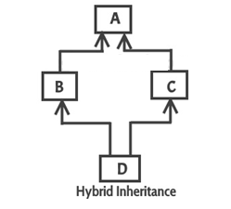

#include<iostream>

usingnamespace std;
classA
{
double x;

public:
A(doublex)
{
this->x=x;
cout<<"A's Constructor"<<endl;
}

double getX()
{
return x;
}

~A()
{
cout<<"A's Destructor "<<endl;
}
};

classB
{
double y;

public:
B(doubley)
{
this->y=y;
cout<<"B's Constructor"<<endl;

}

Double getY()
{
return y;
}

~B()
{
cout<<"B's Destructor"<<endl;
}
};

classC: publicA, publicB//order of constructor depends on this sequence so A's first and B's second and then C
{
double z;
public:
C(doublex, doubley, doublez ):A(x), B(y)
{
this->z=z;
cout<<"C's Constructor"<<endl;
}

doublegetZ()
{
return z;
}

~C()
{
cout<<"C's Destructor"<<endl;

}
};

intmain()
{

CcObj(1.0, 2.0, 3.0);

cout<<cObj.getX()<<endl;
cout<<cObj.getY()<<endl;
cout<<cObj.getZ()<<endl;

cout<<endl<<endl;
return 0;
}

